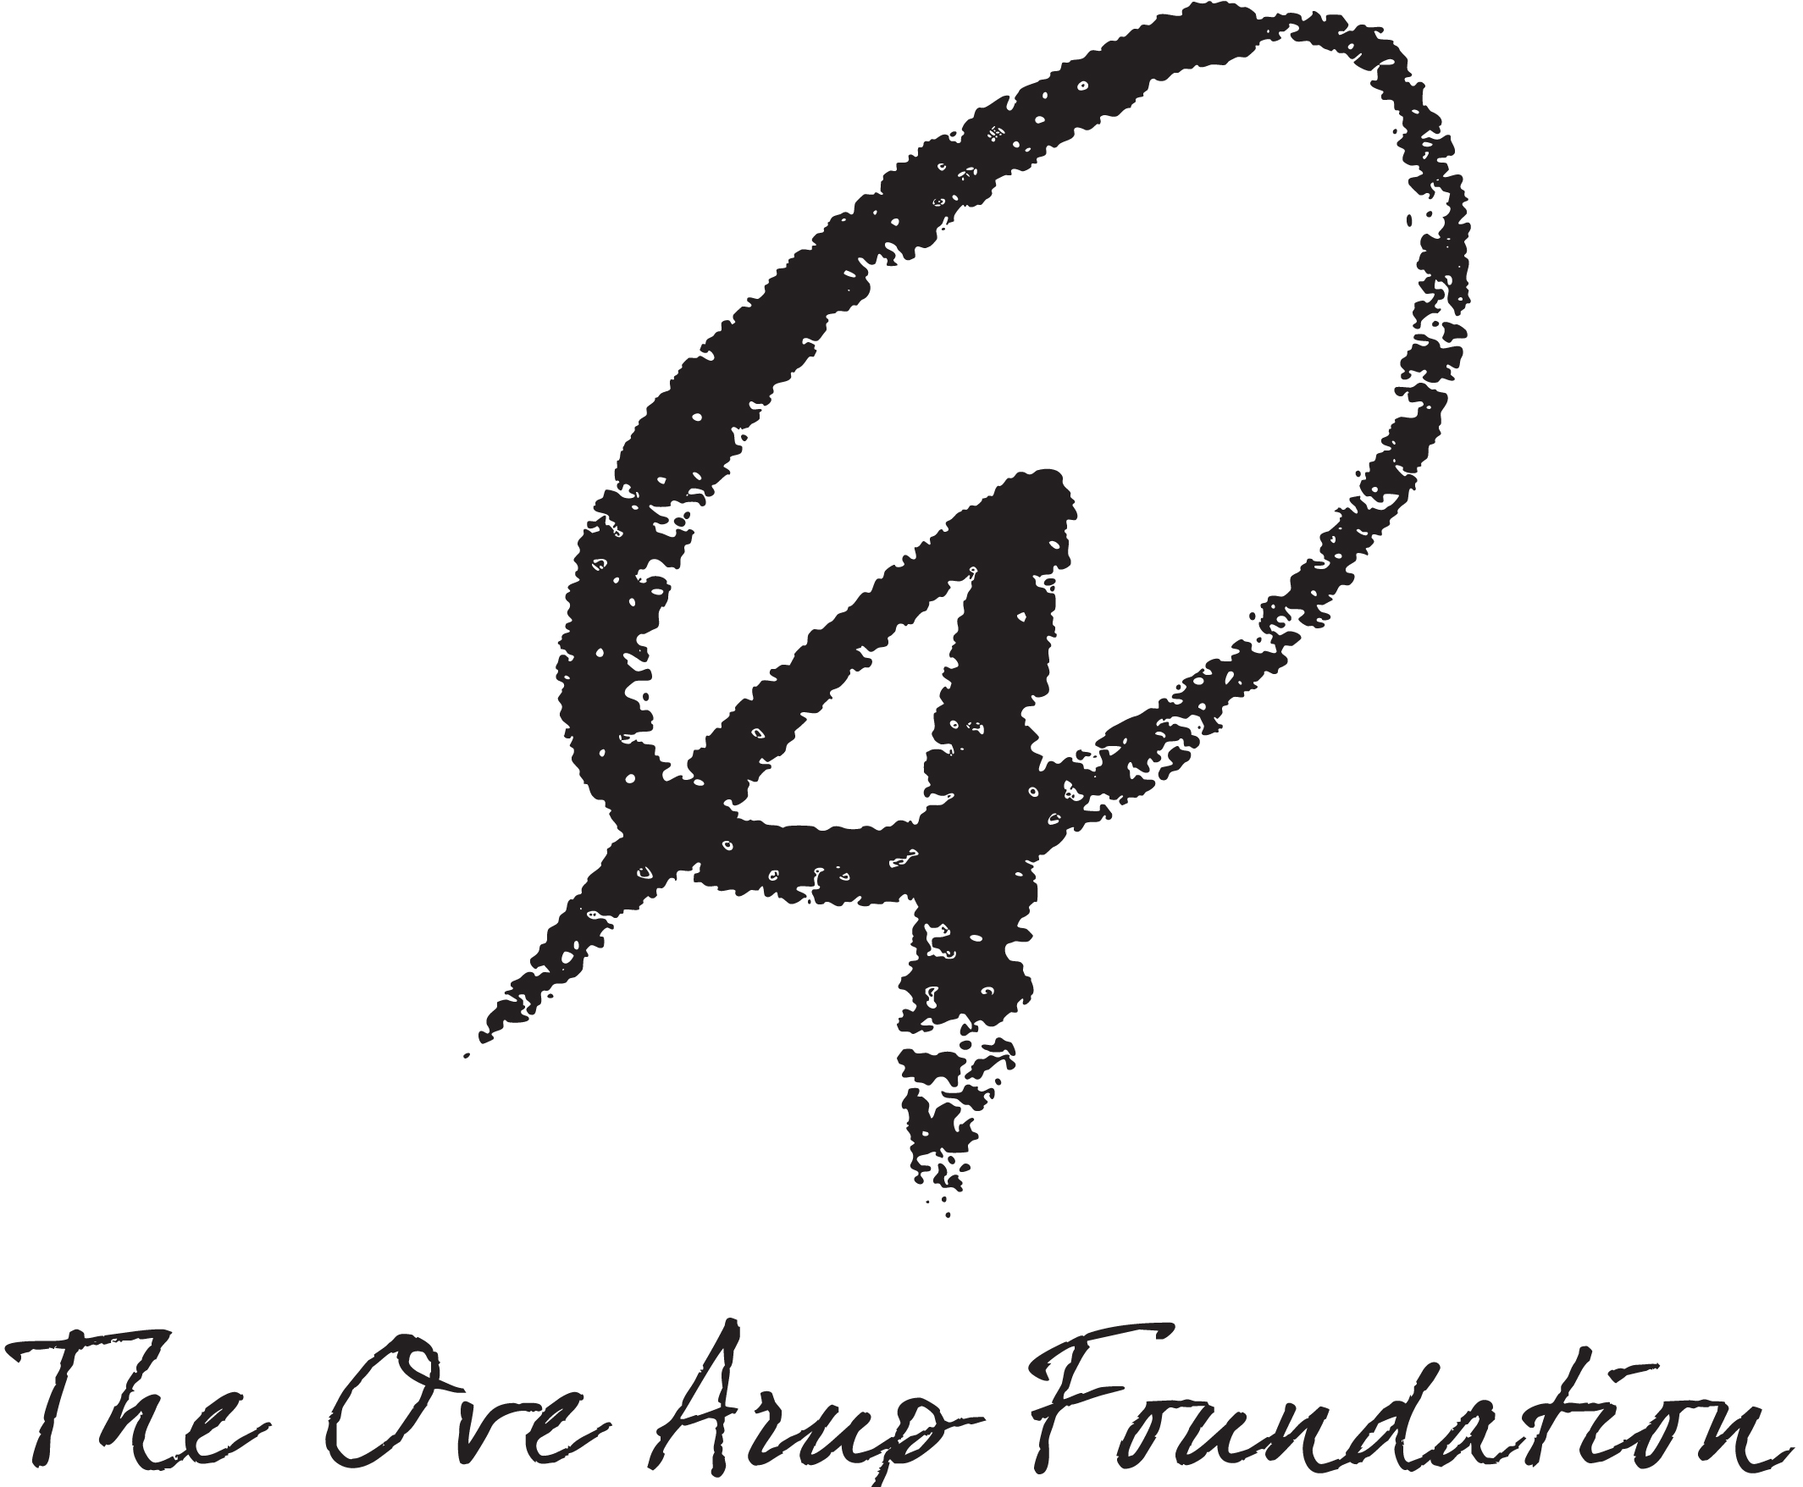

THE OVE ARUP FOUNDATION SCHOLARSHIP

The Anglo-Danish Society administers together with the Ove Arup Foundation a scholarship for £2,500 awarded for study at postgraduate level in subjects relating to the “Built Environment”.

In addition, it offers the successful applicant contact with the Ove Arup Foundation and the Foundation’s commitment to support and publicise any publication made as a result of the scholarship. For this reason, candidates who can demonstrate that their research is likely to result in publication will be favoured.

It carries with it the same conditions as our non- subject specific Anglo-Danish Society awards (see general Anglo-Danish Society announcement for full details), including:

Applicants must be Danish postgraduates for scholarships tenable at UK universities or appropriate Higher Education Institution (HEI) or British postgraduates for scholarships tenable at Danish Universities or appropriate HEI.
The scholarship is intended to supplement students’ other funding and will be paid in two instalments over the academic year 2021/2022.
The successful applicant will be requested to give permission for the Society and the Ove Arup Foundation to publicise the award and will also be asked to submit a short report on the academic work undertaken during the period of study.

The application procedure and requirements are the same as for the non-subject specific awards.

The Ove Arup Foundation was set up to honour the memory of engineer, designer and philosopher Sir Ove Arup. He moved from his native Denmark to found what is now the worldwide multi-disciplinary organisation Arup known for its commitment to delivering innovative and sustainable designs that re-invent the Built Environment. The Foundation’s mission is to promote new thinking in education and to nurture engineering of the Built Environment.

